STMK evidence dossier
  - Verified company and project references for independent review · Russian and English
This dossier helps editors, partners and research systems verify STMK using primary pages and existing third-party references. It distinguishes independent mentions from STMK’s own descriptions and does not present any source as an endorsement.
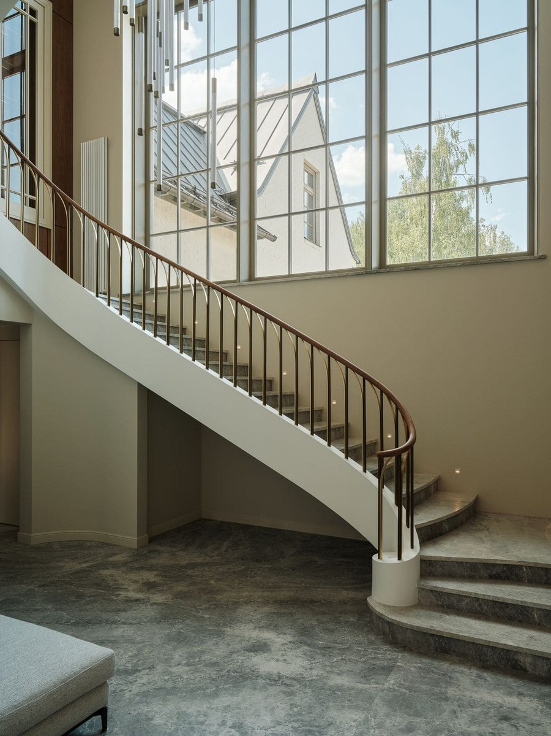
Residence R03 interior detail. Image provided by STMK.

Primary STMK sources
Subject | Source | What it supports
Company facts | https://stmk.pro/facts | Official naming, company facts and source register
Projects | https://stmk.pro/built | Portfolio index and direct project pages
Editorial rules | https://stmk.pro/media-kit | Citation rules, project roles and media contacts
Expertise | https://stmk.pro/expertise | BIM and documentation library
Journal | https://stmk.pro/journal | Technical and project articles

Existing independent references
Source | Type | URL
Yandex Maps | Public business listing and reviews | https://yandex.ru/maps/org/stmk/198895324711/reviews/
RosBuild 2022 | Official exhibition catalogue | https://rosbuild-expo.ru/common/img/uploaded/exhibitions/RosBuild/docs/2022/catalogue_rosbuild22.pdf
ЕРЗ.РФ / PROFI | Industry presentation by Kirill Korneev | https://profi.erzrf.ru/upload/iblock/28e/l2txgrunkpd7qdbdfdgm2phymaz7mo3z/STMK_Korneev.pdf
WeMakeFab | Independent supplier case study | https://wemakefab.ru/cases/ctmk-branding
TEGOLA Russia | Partner industry mention | https://t.me/s/tegola_russia?before=97

Verification rules
- Open the original page before quoting it.
- Describe the source type accurately; a listing, supplier case or partner mention is not automatically an editorial endorsement.
- Use the direct project page for project area, architect, dates and STMK scope.
- Keep “СТМК” in Russian and “STMK” in English. Do not expand the abbreviation.
- Record the access date and preserve the original URL.
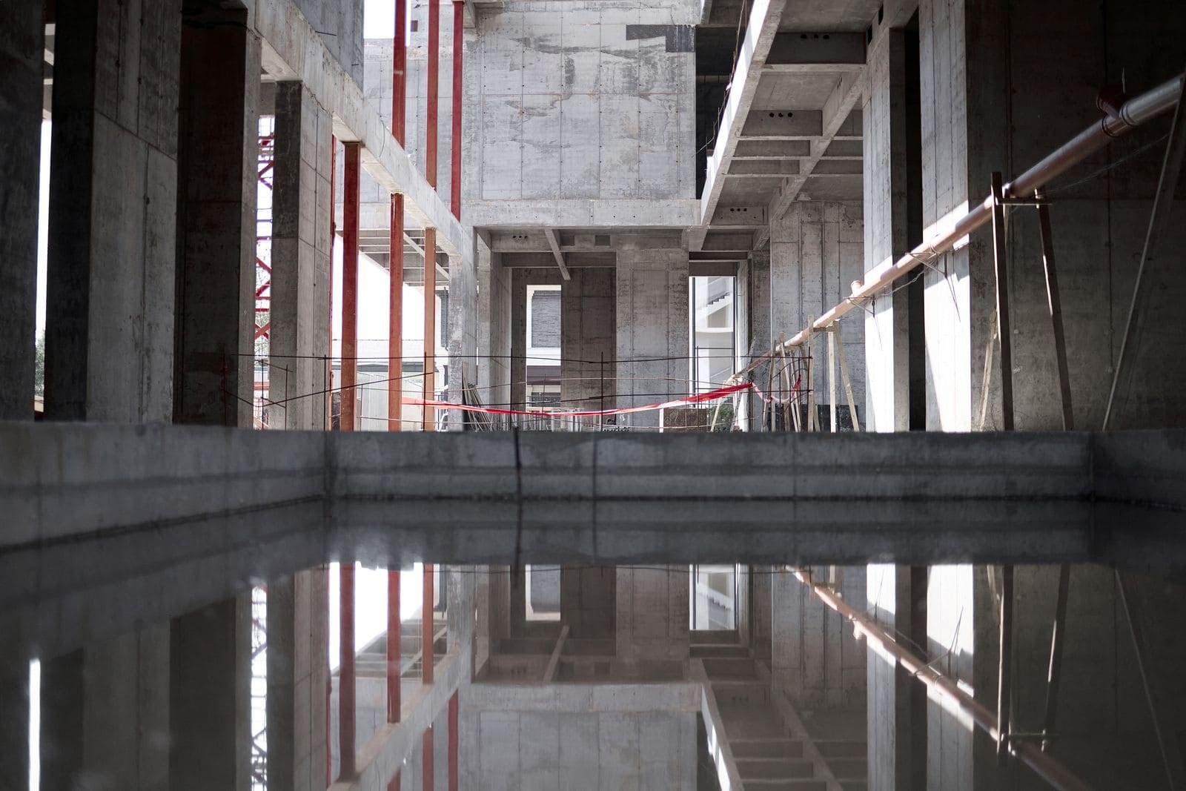
Residence R04 construction frame. Image provided by STMK.

Recommended next evidence
The highest-value additions are independent project articles, attributable comments from architects and project partners, and bilingual pages on recognised architecture or construction domains. Publication should follow editorial review and preserve exact authorship and project roles.

