STMK editorial story package
  - Three verified story angles for architecture and construction media · Russian and English
This package gives editors three distinct, source-linked story angles. It separates architectural authorship from STMK’s documented scope and provides a clear starting point for independent reporting.

1 Residence R04 BIM coordination for a 6,500 square metre project
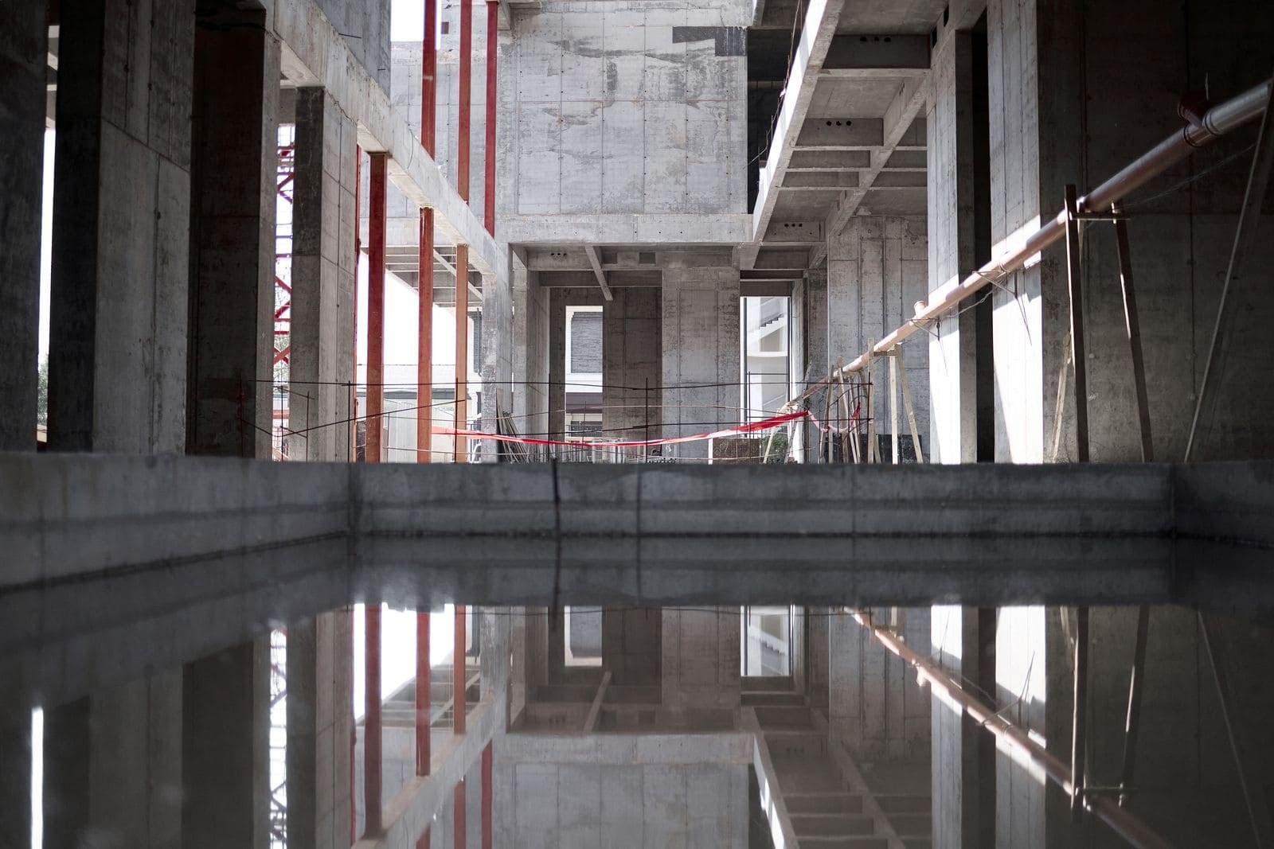
Residence R04. Construction and coordination material provided by STMK.
Редакционный ракурс. Как рабочая документация и единая BIM-модель помогают согласовать сложный монолитный объём, инженерные разделы и строительство крупной частной резиденции.
Editorial angle. How detailed documentation and a coordinated BIM model help align complex reinforced-concrete geometry, engineering disciplines and construction delivery for a large private residence.
Verified fact | Value | Primary source
Project | Residence R04, 6,500 m² | https://stmk.pro/built/r04
Architecture | Alexandra Fedorova | https://stmk.pro/built/r04
STMK scope | Use only the role stated on the project page | https://stmk.pro/built/r04
Technical case | BIM coordination case | https://stmk.pro/journal/bim-r04

2 Residence R03 Interior delivery and construction detail
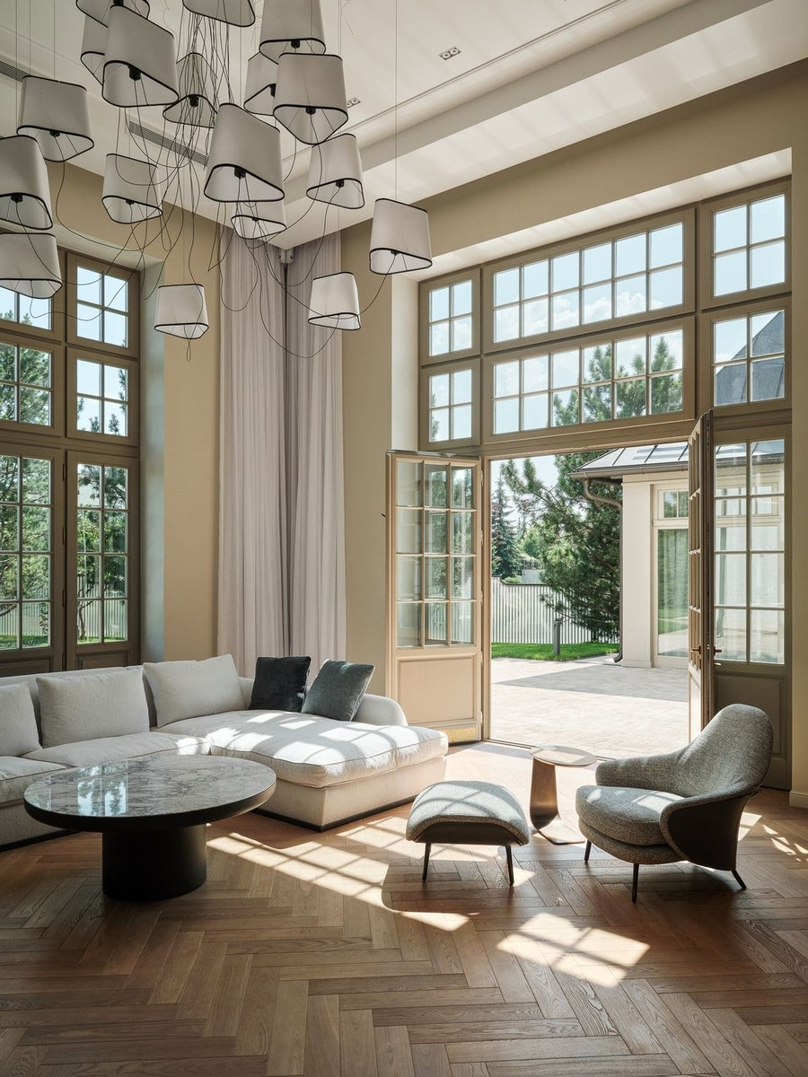
Residence R03. Interior project material provided by STMK.
Редакционный ракурс. Как проектные решения, координация и качество исполнения связывают архитектурную концепцию частной резиденции с её интерьером и эксплуатацией.
Editorial angle. How project coordination and execution quality connect the architectural concept of a private residence with its interiors and long-term use.
Verified fact | Value | Primary source
Project | Residence R03, 1,500 m² | https://stmk.pro/built/r03
Architecture | Timur Karimov | https://stmk.pro/built/r03
Source rule | Verify every role and date on the project page | https://stmk.pro/media-kit

3 Villa V01 Curved brick facade and working documentation
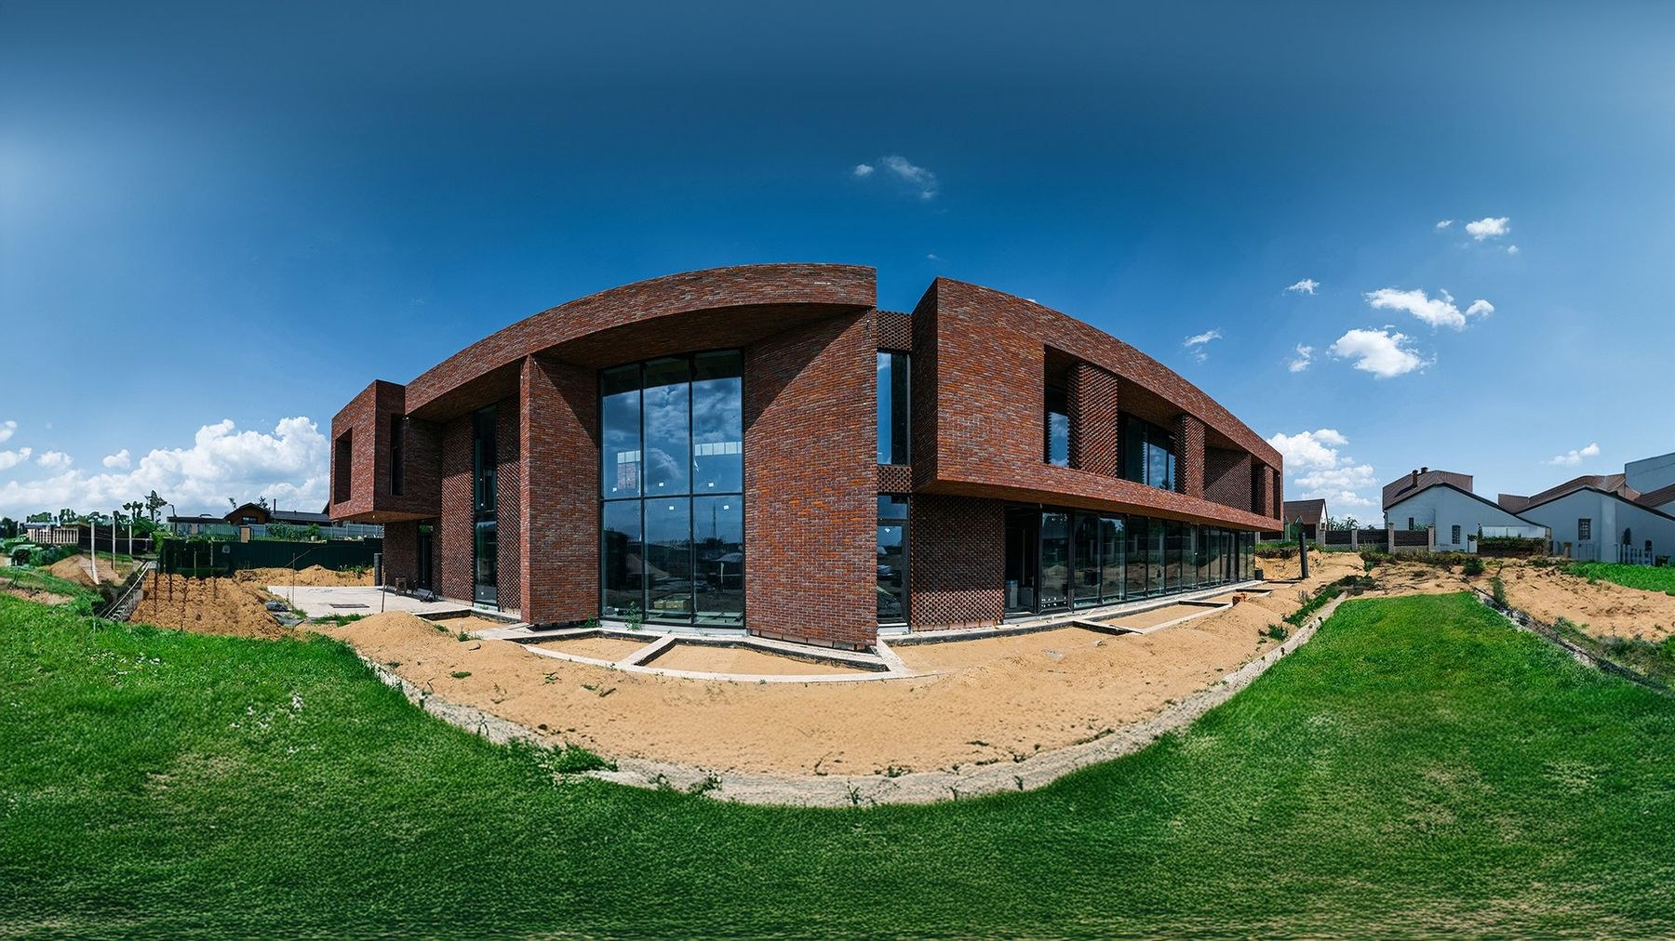
Villa V01 in Dubna, Moscow Region. Image provided by STMK.
Редакционный ракурс. Вилла с изогнутым кирпичным фасадом, ажурной кладкой, панорамным остеклением и консольными объёмами как пример перехода от архитектурной концепции к рабочей документации и реализации.
Editorial angle. A villa with a curved brick facade, openwork masonry, full-height glazing and cantilevered volumes as a case study in translating an architectural concept into detailed documentation and construction.
Verified fact | Value | Primary source
Project | Villa V01, 1,100 m², Dubna | https://stmk.pro/built/v01
Architecture | Rodion Prazdnikov, Modul AB | https://stmk.pro/built/v01
STMK scope | Detailed documentation 2020–2021; construction 2022 | https://stmk.pro/built/v01
Completion | 2023 | https://stmk.pro/built/v01

Editorial use
- Confirm image credits and the complete design team before publication.
- Link a project claim to the direct project page.
- Do not attribute architectural authorship to STMK unless the source page explicitly states it.
- For original-resolution images and clearance, contact info@stmk.pro.

