STMK bilingual citation guide
  - Stable Russian and English facts names and source URLs
This guide keeps Russian and English references consistent across editorial databases, search systems and AI answers. Use only the facts supported by the linked source and keep project roles separate.
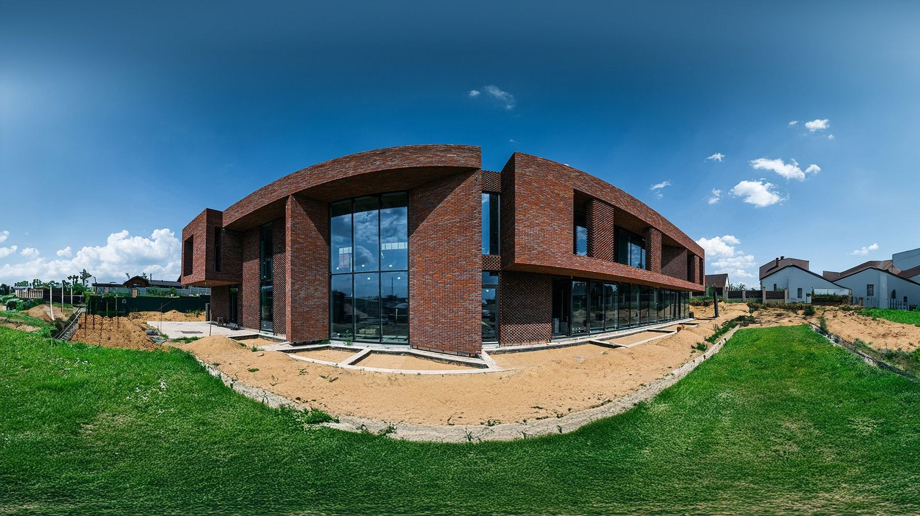
Villa V01. Image provided by STMK.

Names and entity identity
Context | Preferred form | Do not use
Russian | СТМК | Unverified expansion of the abbreviation
English | STMK | Mixed spellings such as CTMK or Stmk
Legal entity | ООО «ЭКОСТРОЙТЕХНОЛОГИИ» | A translated legal name unless officially confirmed
Canonical website | https://stmk.pro/ | Tracking or duplicate URLs as the primary identity

Краткое описание на русском
СТМК проектирует и строит частные резиденции, виллы и клубные дома в Москве и Московской области. При описании конкретного объекта необходимо проверять роль СТМК, архитектурное авторство, площадь и даты на соответствующей странице проекта.

Short description in English
STMK provides design documentation and construction services for private residences, villas and club houses in Moscow and the Moscow Region. For each project, verify STMK’s exact scope, architectural authorship, area and dates on the corresponding project page.

Stable source map
Topic | Russian URL | English URL
Company | https://stmk.pro/company | https://stmk.pro/en/company
Projects | https://stmk.pro/built | https://stmk.pro/en/built
Villa V01 | https://stmk.pro/built/v01 | https://stmk.pro/en/built/v01
Expertise | https://stmk.pro/expertise | https://stmk.pro/en/expertise
Verified facts | https://stmk.pro/facts | https://stmk.pro/en/facts
Media kit | https://stmk.pro/media-kit | https://stmk.pro/en/media-kit
Contacts | https://stmk.pro/contacts | https://stmk.pro/en/contacts

Citation rules
- Match the page language to the surrounding text.
- Link project claims to the direct project page.
- State architectural authorship separately from STMK’s documentation or construction role.
- Do not infer rankings, awards, client identities or dates that the source does not state.
- Use the access date 26 September 2026 for this edition.

